How to use GO2Cam for M16 machine

Summary

Machine description 2

Main spindle position 2

Rework spindle position 3

How to set Tool offset number 4

How to choose which axis will work for turret 5

Set Pattern number 6

Broaching tool definition 8

Forming tool definition for internal use 9

# Machine description

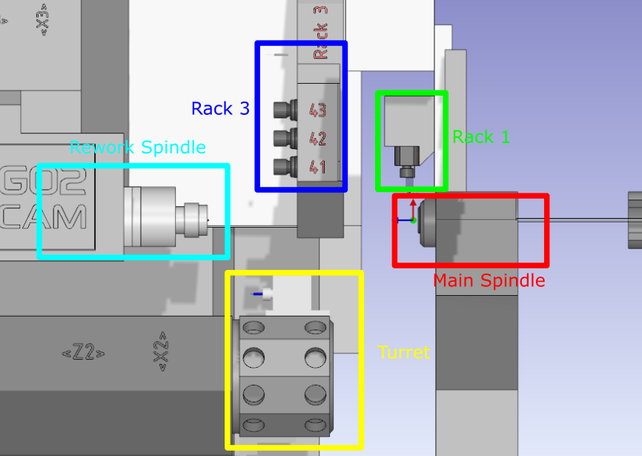

# Main spindle position

After programming the whole part

Right click on “Stock”, then “Setting stock/chuck”

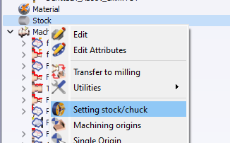

Then click on button circle in red. A new window appears.

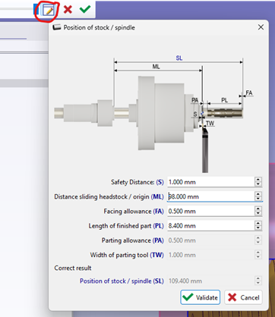

This window, will compute the right position of chuck to machine part.

# Rework spindle position

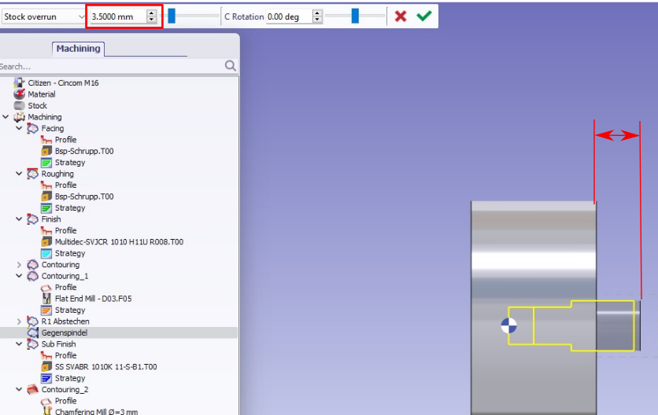

Parameter #821 at the end of program. It’s the distance from the flange to the origin of the part for rework operations.

In the sample we have an allowance of 0.5mm for parting operation. So if we set 3.5 mm overrun and have 0.5 allowance in parting operation, we will have 3.0 for parameter #821

In micron inside program

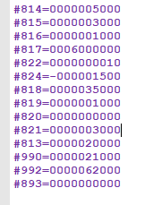

# How to set Tool offset number

Modify the L Comp value if needed

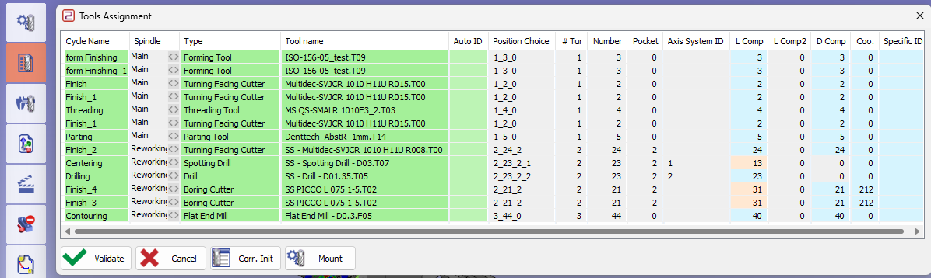

Information : for the milling tool in rack 3 for sub spindle, the tool offset number is automatically set to 40

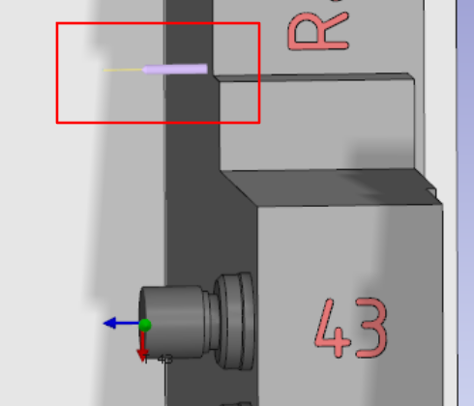

# How to choose which axis will work for turret

Depending of which axis will work for the turret, you have to set locking of axis column.

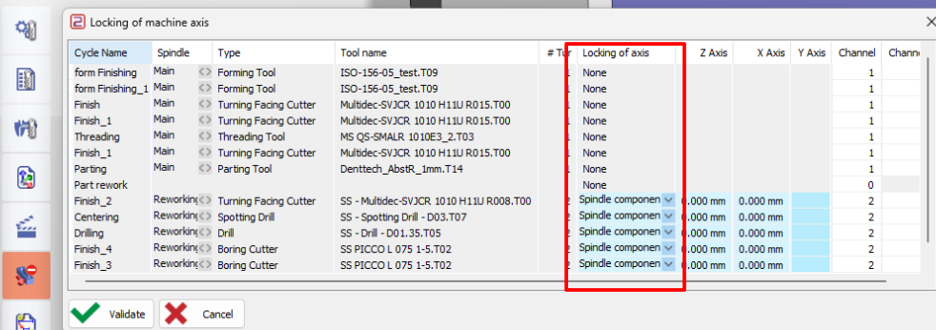

|  |  |  |
| --- | --- | --- |
| **Case** | **Setting** | **Illustration** |
| Turret works on main spindle with Z1 axis |  |  |
| Turret works on sub spindle with Z2 axis |  |  |

# Set Pattern number

|  |  |
| --- | --- |
|  | Go in the synchronization tool menu |

Use rework at end for scenario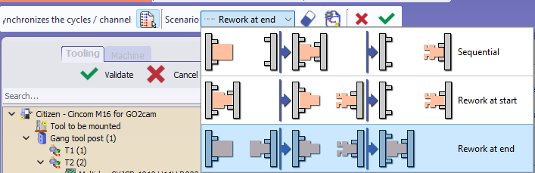

Set synchronization between first operations of main spindle and second spindle by drag drop between the top of two operations

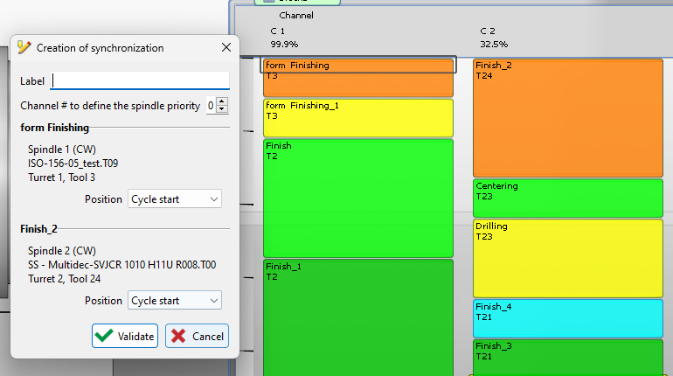

|  |  |
| --- | --- |
|  | Click on button to display the list of synchro table |

Define pattern in the column pattern

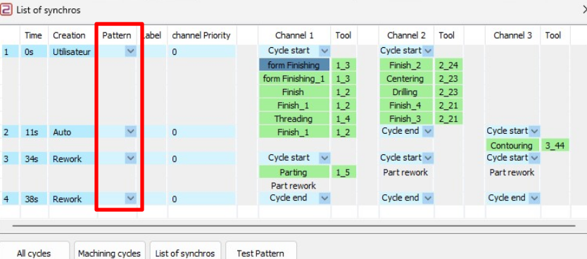

Pattern before parting rework operation will be always “G750”

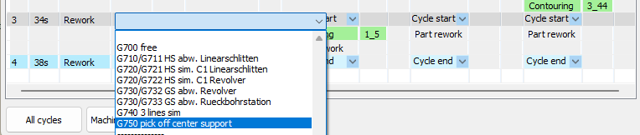

Others patterns depend of operations coming after. If necessary, you can add synchronizations between operations to assign new pattern.

A main pattern change should be always output on three channels.

If needed to output sub pattern like G711 and G712 in only one channel, you can assign pattern by right click on the operation in the gantt diagram. Then select in the array “List of synchros”

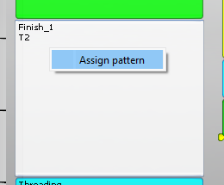

Help : If you select an operation of the Gantt, you can preview on the machine the tool used for this operation

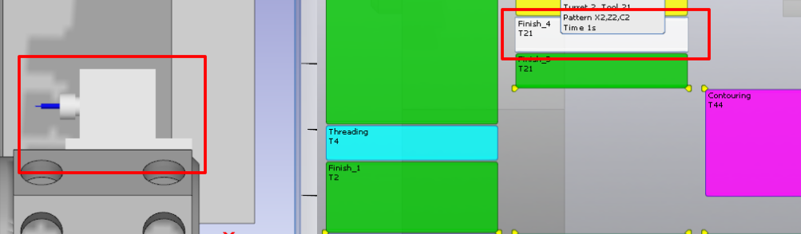

# Broaching tool definition

Definition of tool dimension to be able to have correct offset in NC program

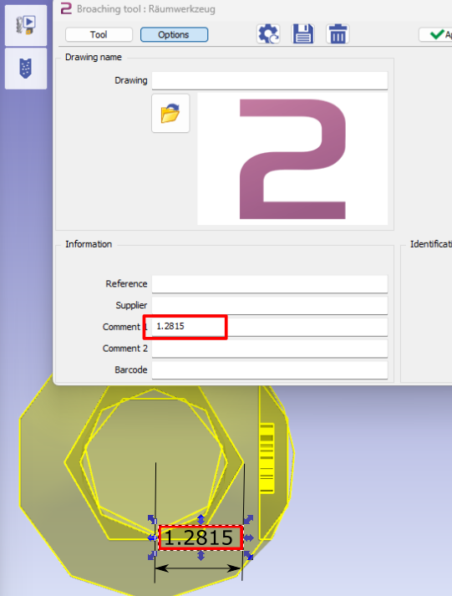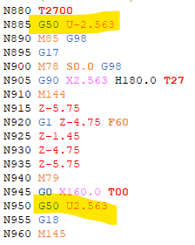

# Forming tool definition for internal use

Right hand tool with form insert for internal machining on Rework Spindle

This tool can be used with those cycles :

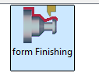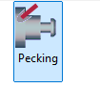

|  |  |
| --- | --- |
| Go inside “Clamping / Tool holder” module  Import 3D model |  |
| Move the tool holder in the right position  The driven point of the insert has to be on the origin.  The body of insert holder has to be along X axis.  The insert has to be opposite of Y axis |  |
| Go in Creation then tool holder |  |
| Define System of axis 0 like on the screen shot    Z axis : along insert holder  Origin : center on the insert holderX axis : opposite to the insert |  |
| Define System of axis 1  Z direction : normal to the face of the insert  Origin : piloted point of insert  X direction : same than Z axis of system of axis 0 |  |
| Design the form of insert in wireframe on the solid |  |
| Remove shape of tool insert from the insert holder.  The height will be minus the thickness of your insert |  |
| Save insert holder with unique name |  |
| Copy geometry of insert |  |
| Go back to workshop  Go in the “Forming tools / Tools libraries” module |  |
| Paste the 2D geometry of insert |  |
| Go in “Creation” then “Form Insert”. Then creation of form insert XML |  |
| Select all the geometry elements  Right click  Confirm selection  Save insert shape with naming it. |  |
| Set the parameters of insert.  Think to set the Thickness equal to the depth of insert pocket created in the insert holder. |  |
| Add insert holder  1 : Add tool holder  2 : Select Solid Insert Holder  3: Choose the right symbol  4 : Set orientation  5 : Save tool |  |
| Final Result |  |
| Tool will be available on the Forming tool selection |  |